

SCD Project Test Report
Topic:
Arabic Text editor
Submitted by:
Roll No. | Name
22F-3706 | Huzaifa Asif
22F-3708 | Syed Muhammad Taqi
22F-3722 | Muhammad Abdullah

Submitted to:
Dr. Affan Rauf

Test Inputs:
1. Create File in DB
Success Case
- File Name: AyatUlQursi22222
- Content: “الله لا إله إلا هو الحي القيوم”
- Expected Result: true
Failure Case
- File Name: null
- Content: “ٱللَّهُ لَآ إِلَـٰهَ إِلَّا هُوَ ٱلْحَىُّ ٱلْقَيُّومُ ۚ لَا تَأْخُذُهُۥ سِنَةٌۭ وَلَا نَوْمٌۭ ۚ لَّهُۥ مَا فِى ٱلسَّمَـٰوَٰتِ وَمَا فِى ٱلْأَرْضِ ۗ مَن ذَا ٱلَّذِى يَشْفَعُ عِندَهُۥٓ إِلَّا بِإِذْنِهِۦ ۚ يَعْلَمُ مَا بَيْنَ أَيْدِيهِمْ وَمَا خَلْفَهُمْ ۖ وَلَا يُحِيطُونَ بِشَىْءٍۢ مِّنْ عِلْمِهِۦٓ إِلَّا بِمَا شَآءَ ۚ وَسِعَ كُرْسِيُّهُ ٱلسَّمَـٰوَٰتِ وَٱلْأَرْضَ ۖ وَلَا يَـُٔودُهُۥ حِفْظُهُمَا ۚ وَهُوَ ٱلْعَلِىُّ ٱلْعَظِيمُ”
- Expected Result: false

2. Update File in DB
Success Case
- Existing File ID: ID of file created using createFileInDB method
- File Name: AyatUlQursi
- Content: “سم الله الرحمن الرحيم”
- Expected Result: true
Failure Case
- Non-Existing File ID: 999
- File Name: NonExistingFile
- Content: “Content”
- Expected Result: false

3. Delete File in DB
Success Case
- File ID: ID of the first file retrieved using getFilesFromDB
- Expected Result: true
Failure Case
- Non-Existing File ID: 99999999
- Expected Result: false

4. Get Files from DB
Empty Database
- Action: Call getFilesFromDB
- Expected Result: List of documents, not null
Database with Data
- Action: Call getFilesFromDB after adding files
- Expected Result: List of documents, not null

5. Transliterate in DB
Success Case
- Content: “الله لا إله إلا هو ...”
- Page Number: 1
- Expected Result: Transliteration output, not null
Failure Case
- Page Number: -1
- Content: “نص عربي”
- Expected Result: null

6. Lemmatize Words
- Input String: “حبيبي”
- Expected Result: Map of lemmas, not null

7. Extract POS
- Input String: “حبيبي”
- Expected Result: Map of POS tags, not null

8. Extract Roots
- Input String: “حبيبي”
- Expected Result: Map of roots, not null

9. Perform TF-IDF
- Document List: ["“", “بسم الله الرحمن الرحيم”]
- Term: “الله لا إله إلا هو”
- Expected Result: tfidfScore >= 0

10. Perform PMI
- Input Content: “ٱللَّهُ لَآ إِلَـٰهَ إِلَّا هُوَ ٱلْحَىُّ ٱلْقَيُّومُ ۚ لَا تَأْخُذُهُۥ سِنَةٌۭ وَلَا نَوْمٌۭ ۚ لَّهُۥ مَا فِى ٱلسَّمَـٰوَٰتِ وَمَا فِى ٱلْأَرْضِ ۗ مَن ذَا ٱلَّذِى يَشْفَعُ عِندَهُۥٓ إِلَّا بِإِذْنِهِۦ ۚ يَعْلَمُ مَا بَيْنَ أَيْدِيهِمْ وَمَا خَلْفَهُمْ ۖ وَلَا يُحِيطُونَ بِشَىْءٍۢ مِّنْ عِلْمِهِۦٓ إِلَّا بِمَا شَآءَ ۚ وَسِعَ كُرْسِيُّهُ ٱلسَّمَـٰوَٰتِ وَٱلْأَرْضَ ۖ وَلَا يَـُٔودُهُۥ حِفْظُهُمَا ۚ وَهُوَ ٱلْعَلِىُّ ٱلْعَظِيمُ”
- Expected Result: Map of PMI scores, not null

11. Perform PKL
- Input Content: “ٱللَّهُ لَآ إِلَـٰهَ إِلَّا هُوَ ٱلْحَىُّ ٱلْقَيُّومُ ۚ لَا تَأْخُذُهُۥ سِنَةٌۭ وَلَا نَوْمٌۭ ۚ لَّهُۥ مَا فِى ٱلسَّمَـٰوَٰتِ وَمَا فِى ٱلْأَرْضِ ۗ مَن ذَا ٱلَّذِى يَشْفَعُ عِندَهُۥٓ إِلَّا بِإِذْنِهِۦ ۚ يَعْلَمُ مَا بَيْنَ أَيْدِيهِمْ وَمَا خَلْفَهُمْ ۖ وَلَا يُحِيطُونَ بِشَىْءٍۢ مِّنْ عِلْمِهِۦٓ إِلَّا بِمَا شَآءَ ۚ وَسِعَ كُرْسِيُّهُ ٱلسَّمَـٰوَٰتِ وَٱلْأَرْضَ ۖ وَلَا يَـُٔودُهُۥ حِفْظُهُمَا ۚ وَهُوَ ٱلْعَلِىُّ ٱلْعَظِيمُ”
- Expected Result: Map of PKL scores, not null

12. Stem Words
- Input String: “حبيبي”
- Expected Result: Map of stems, not null

13. Segment Words
- Input String: “حبيبي”
- Expected Result: Map of segmented words, not null

Test Paths and Requirements:

TC1 Create:
Valid Test-Path: {[1,2,5,10,11,12,13,14,15,13,16,17,18,29,17,20,21,22,23,21,24,25,26,27,25,28,29,30,31,29,32,33,34,35,33,36,37,38,39,37,40,11,41,42]}
Invalid Test-Path:
{[1,2,3,4], [1,2,5,6,7]}
TR(PC):
{[1,2,3,4], [1,2,5,6,7], [1,2,5,10,11,12,13,14,15,16,17,18,19,17,20,21,22,23,21,24,25,26,27,25,28,29,30,31,
29,32,33,34,35, 33,36,37,38,39,40,11,41,42]}

TC2 Update:
Valid Test-Path:
{[1,2,5,8,9,10,11,9,12,13,14,15,16,14,17,18,19,20,21,19,22,23,24,25,26,24,27,28,29,
30,31,29,32,33,34,35,36,34,37,38,39,40,41,39,42,43,44]}
Invalid Test-Path:
{[1,2,3,4], [1,2,5,6,7]}
TR(PC):
{[1,2,3,4], [1,2,5,6,7] , [1,2,5,8,9,10,11,9,12,13,14,15,16,14,17,18,19,20,21,19,22,23,24,25,26,24,27,28,29,30,31,29,32, 33, 34,35,36,34,37,38,39,40,41,39,42,43,44]}

TC3 Delete :
Valid Test-Path:
{[1,2,5,6,]}
Invalid Test-Path:
{[1,2,3,4]}
TR(PC):
{[1,2,3,4], [1,2,5,6]}

TC4 Transliterate :
Valid Test-Path:
{[1,2,6,7,9,10]}
Invalid Test-Path:
{[1,2,3,5,6], [1,2,3,4]}
TR(PC):
{[1,2,3,4], [1,2,3,5,6], [1,2,6,7,9,10]}

TC5 GetFilesFromDB :
Valid Test-Path:
{[1,2,6,7,8,9,10,9,11,7,12,13]}
Invalid Test-Path:
{[1,2,3,5], [1,2,3,4]}
TR(PC):
{[1,2,3,4],[1,2,3,5],[1,2,6,7,8,9,10,9,11,7,12,13]}
TC6 Lemma :
Valid Test-Path:
{[1,2]}
TR(PC):
{[1,2]}

TC7 Segment :
Valid Test-Path:
{[1,2]}
TR(PC):
{[1,2]}

TC8 Stems :
Valid Test-Path:
{[1,2]}
TR(PC):
{[1,2]}

TC9 POS-Tagging :
Valid Test-Path:
{[1,2]}
TR(PC):
{[1,2]}

TC10 Root :
Valid Test-Path:
{[1,2]}
TR(PC):
{[1,2]}

TC11 PMI :
TR(PC):
{[1,2]}

TC12 PKL :
TR(PC):
{[1,2]}

TC13 TFIDF :
Valid Test-Path:
{[1,2,3,4,2]}
TR(PC):
{[1,2,3,4,2]}

Control Flow Graph:

Create
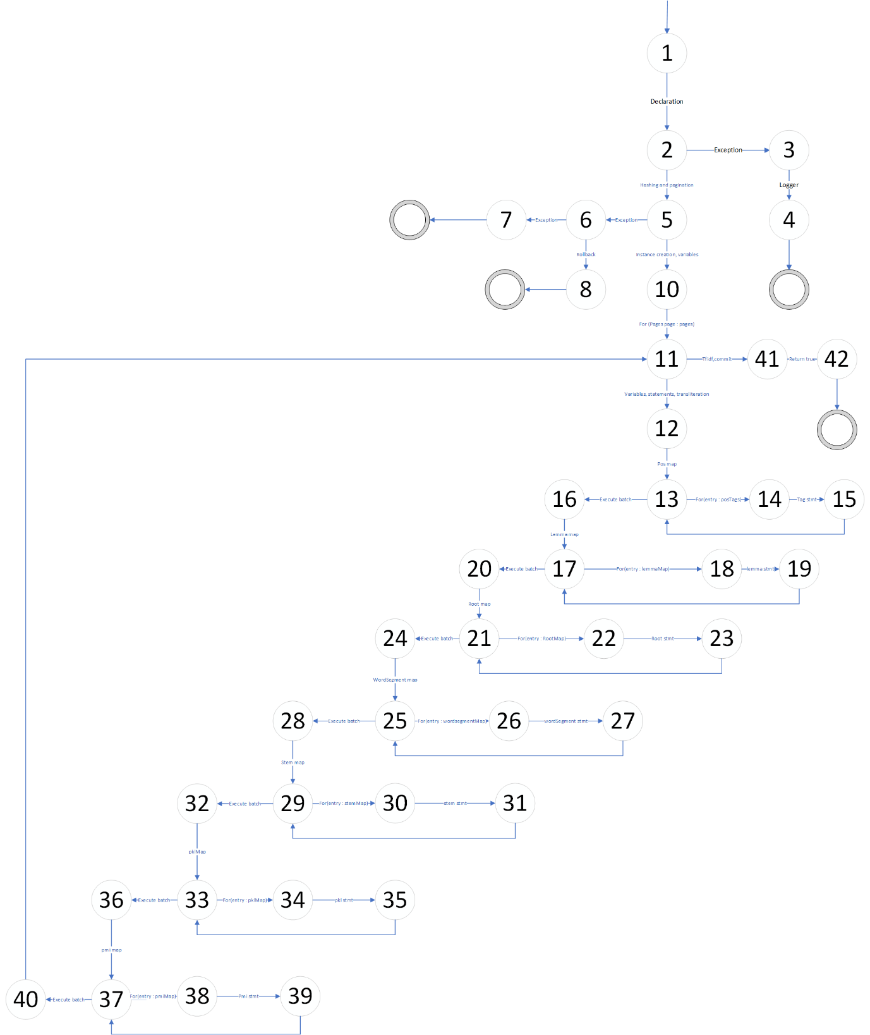

Update
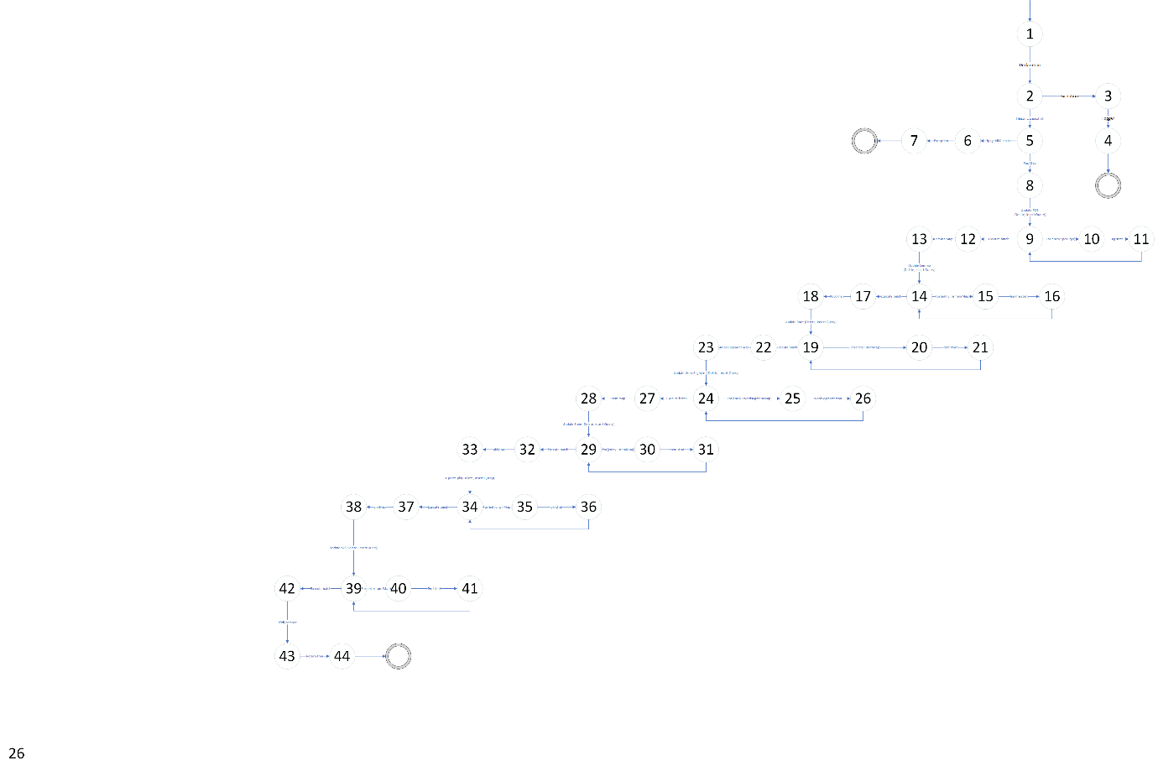

Delete
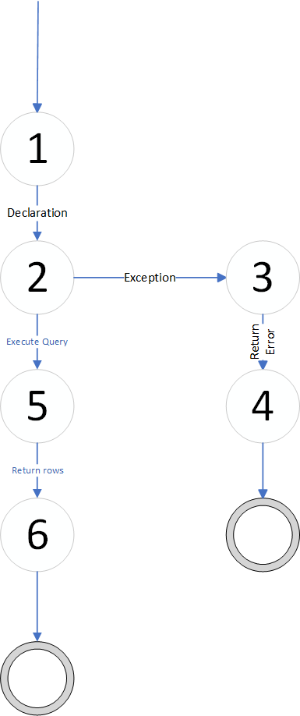

Transliterate
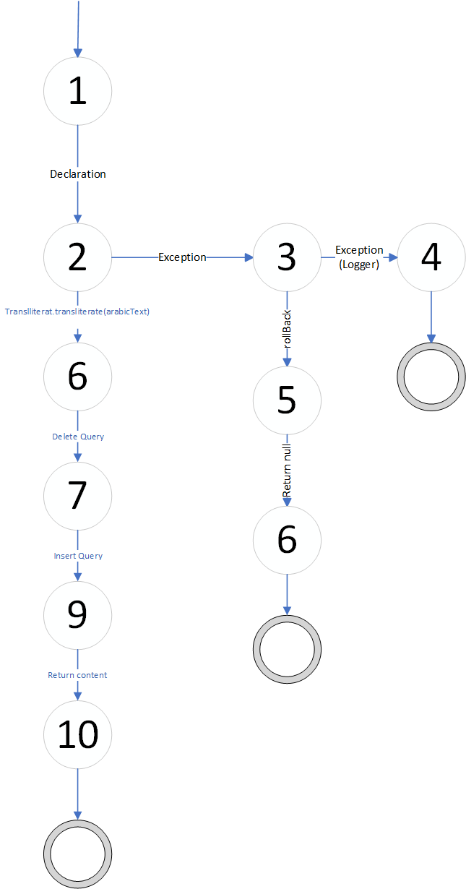

GetFilesFromDB

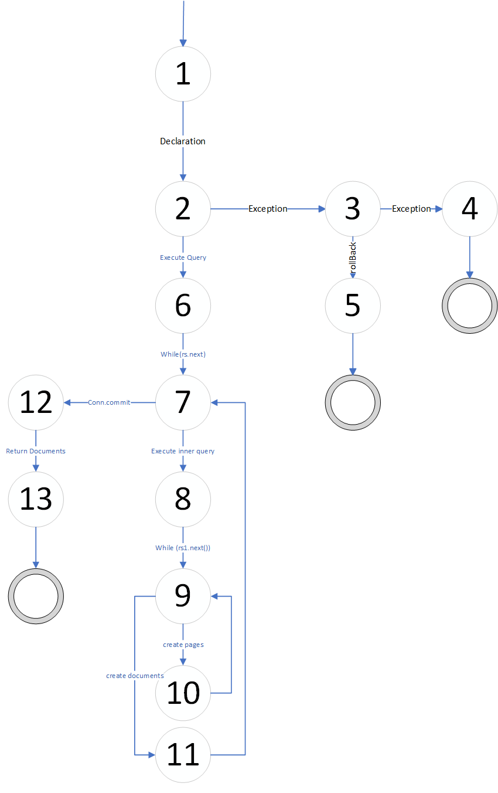
Lemma


Segment


Stems


POS-Tagging


Root


PMI


PKL


TFIDF
